**DAILY ONLINE ACTIVITIES SUMMARY**

|  |  |  |  |  |  |  |  |  |
| --- | --- | --- | --- | --- | --- | --- | --- | --- |
| **Date:** | **18-05-2020** | | | | | **Name:** | **Sinchana** | |
| **Sem & Sec** | **6 B** | | | | | **USN:** | **4AL17CS117** | |
| **Online Test Summary** | | | | | | | | |
| **Subject** | | **CNSC** | | | | | | |
| **Max. Marks** | | **60** | | **Score** | | | **43** | |
| **Certification Course Summary** | | | | | | | | |
| **Course** | **Selenium Web Driver with Java** | | | | | | | |
| **Certificate Provider** | | | **Dmitry Shyshkin**  **(Udemy)** | | **Duration** | | | **6.5 hours** |
| **Coding Challenges** | | | | | | | | |
| **Problem Statement: 1. Frequency of character of a given string. 2.Ping Pong. 3.Triplet.**  **4.Anagram** | | | | | | | | |
| **Status: Success** | | | | | | | | |
| **Uploaded the report in Github** | | | | | **Yes** | | | |
| **If yes Repository name** | | | | | **coding** | | | |
| **Uploaded the report in slack** | | | | | **Yes** | | | |

Online Test Details: (Attach the snapshot and briefly write the report for the same)

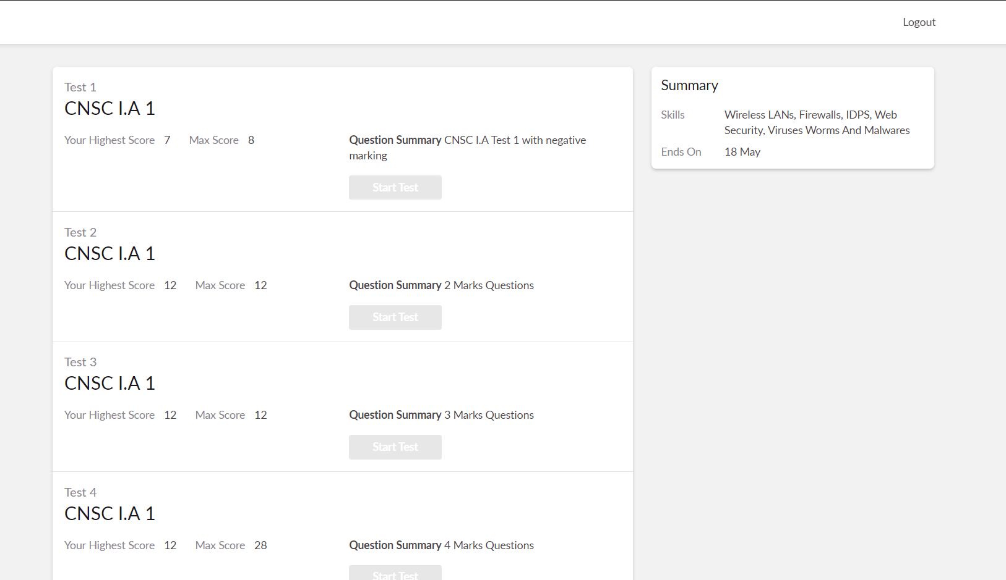

The test was held between 9:20 am to 10:00 am. It consisted of 4 rounds and the total marks assigned was 60.The above snapshot is the output of my 1st IA test.

Certification Course Details: (Attach the snapshot and briefly write the report for the same)

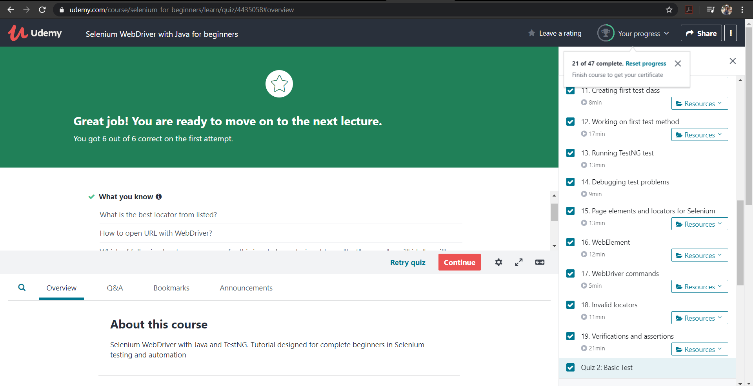

I have learnt to Set up test automation framework with Selenium WebDriver and to automate the WebDriver test. Learnt basics of Java for testers and also to execute Selenium tests on different browsers.

Coding Challenges Details: (Attach the snapshot and briefly write the report for the same)

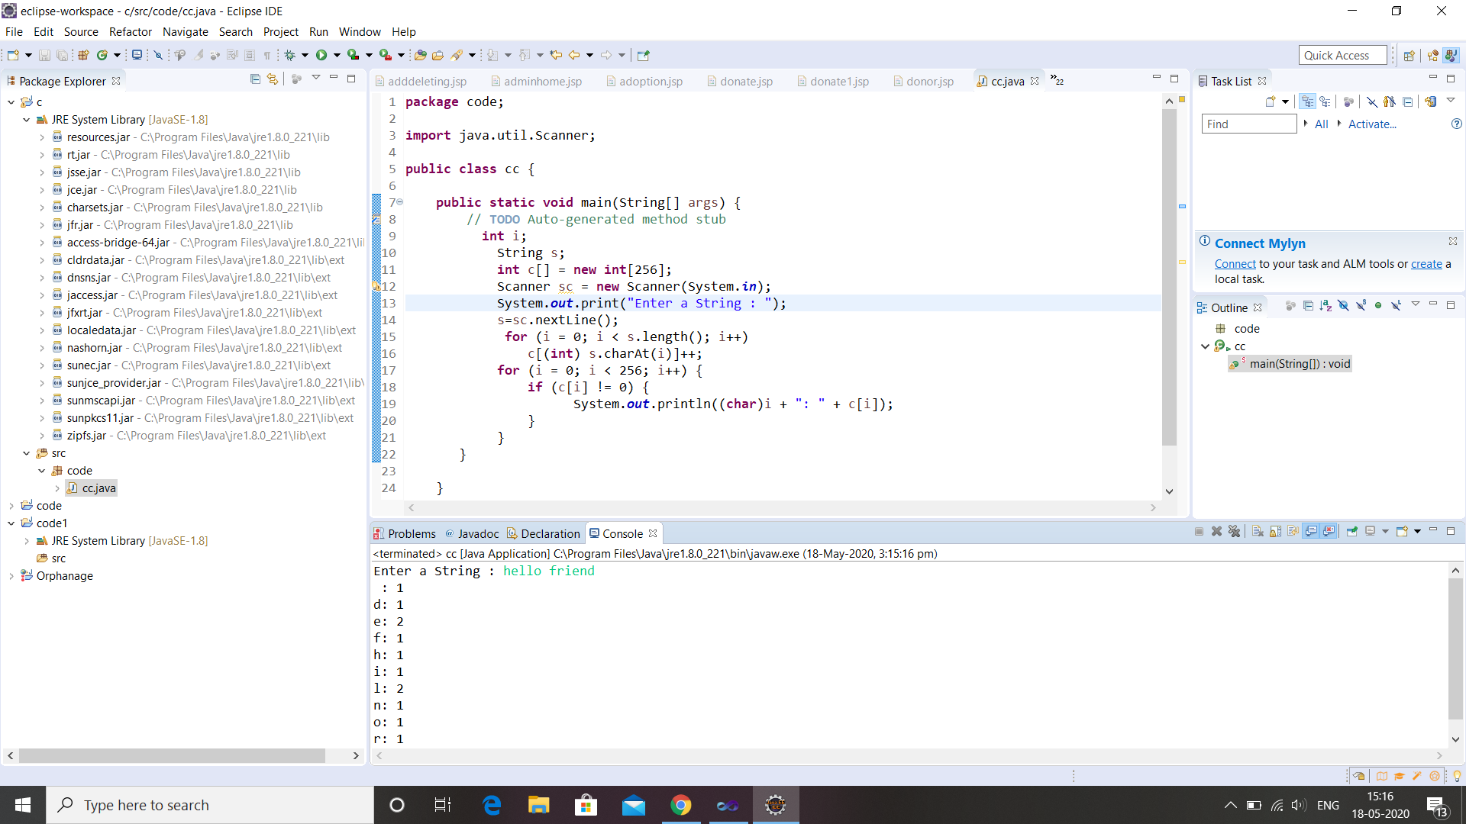

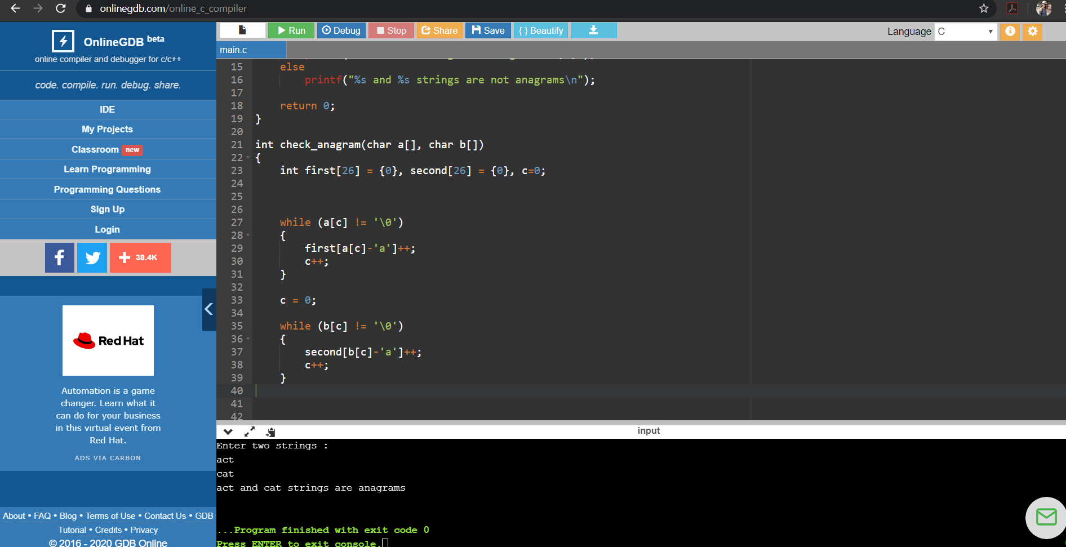

Link for coding in GitHub : <https://github.com/sinchana514/coding>

Link for certificate in GitHub : <https://github.com/sinchana514/certificate>